**layla al-isra wa’l mi’raj; THE NIGHT JOURNEY**

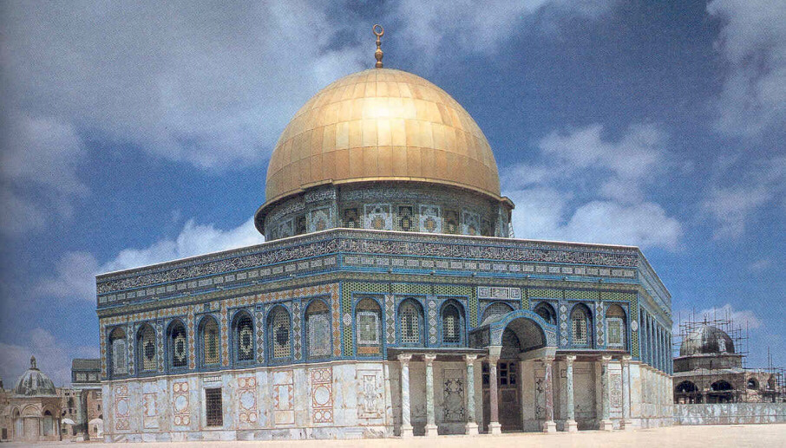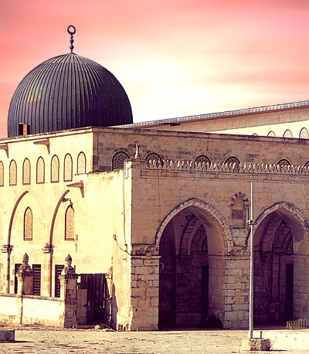 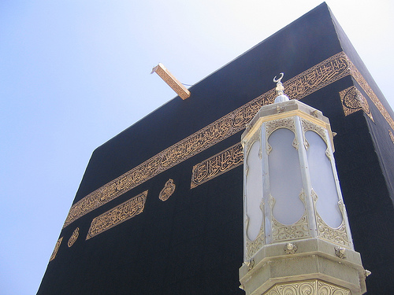

There was one important event that took place during in the year before the Prophet (peace be upon him) migrated to Madina. The Prophet (peace be upon him) was taken on a night journey to the farthest mosque in Jerusalem on a journey known as the Isra and then into the heavens known as the Mi’raj. This was no ordinary journey because normally the journey from Makkah to Jerusalem would take a month if travelling by horse or camel. The journey into the heavens was totally unheard off and hard for people to understand or accept. The prophet (peace be upon him) had completed the whole journey to Jerusalem and then into the heavens during a small part of the night.  
  
The Angel Jibrael accompanied Prophet Muhammad (peace be upon him) throughout the journey. The Prophet (peace be upon him) travelled on an animal called the Buraq which allowed the Prophet (peace be upon him) to travel vast distances in a small period of time.

The Prophet (peace be upon him) was whisked away to the mosque in Jerusalem – al-Masjid al-Aqsa. Here all the prophets were assembled and they prayed Salah together behind prophet Muhammad (peace be upon him). All the prophets from the past were assembled at the same point in time to offer Salah behind the last and final messenger.  
  
After the Salah, the Prophet (peace be upon him) was taken away into the heavens. As the Prophet (peace be upon him) ascended the different heavens, he met many prophets (Adam (as), Yahya (as), Isa (as), Yusuf (as), Harun (as), Ibrahim (as) and Musa (as)) and saw many amazing things. This journey through heaven continued through each heaven until he reached the seventh heaven and was taken to a point called Sidratul Muntaha, where he spoke and saw Allah in person.   
  
When the Prophet (peace be upon him) spoke with Allah, he was given the command for the believers to pray fifty times a day. As the prophet (peace be upon him) descended, he met Musa (as) who advised him that this would be difficult for the believers. Eventually, this number was reduced to five a day.

The five daily prayers were thus made compulsory upon the believers by the command of Allah. It was the will of Allah that the Salah should be reduced to five Salah in a day but still the people who perform them will receive the full reward for the fifty Salah. The Prophet (peace be upon him) then continued his journey through heaven.

Match the word with the correct box.

|  |  |
| --- | --- |
| Jibrael | This is the journey to the heavens. |
| Mi’raj | The one who helped reduced the prayers from 50 to 5. |
| Isra | The special animal which transported the Prophet from Makka to Jerusalem |
| Buraq | The place beyond the seven heavens. |
| Musa. | The angel who was with the Prophet (peace be upon him) during this journey |
| Sidratul Muntaha | This is the night journey from Makka to Jerusalem |

**WORD SEARCH.**

M K G L U F S R L L C W D V U

J C T Q Q H J G Q B V M X T N

I Y I C A W M A I L Y E P R L

M R R X R R Q M R A W Q B A Z

N W H K U T U U K I M C R K F

D G Y L B H F K O H M U X A Z

I M E O A O A Y S S Y S S B X

C Y G M Z M C O R Y T F G A C

Z P M A I Z V Z S I O M H S M

V A L E A R B I J E M Z E Y W

D B S D Z Q A C S A S B C J H

M P Z K P G H B H G G M E P J

T V I G E I S R A N N C O X A

Z W D C T D G L S M T O A T G

D E Z W W O G F O L Y G G H C

BURAQ MUSA ISRA

JIBRAEL KABA MAKKA

MIRAJ MUHAMMAD

The Night Journey

Cut and stick the following events into the correct order.



He saw & spoke to Allah, and was gifted Salah

He reached *Sidratul Muntaha*

Prophet Muhammad led the prayers



He ascended the heaven and met different Prophets

He travelled on the *Buraq* to Jerusalem

The Prophet was resting in Makka